My recommendation for Big Mountain Resort would be increase the vertical drop by 150 feet and install an additional chair lift. Although Big Mountain resort is already the most expensive resort in Montana as shown in the graph below by the dotted line. Increasing the vertical drop by 150 feet and installing an additional chair lift would make the ticket price more valuable by $1.99 which would lead to an increase in revenue of $3,474,638. Big Mountain resort could also add 2 acres of snow making on top of the vertical drop increase and additional chair but I would not recommend this since it would have no effect on the ticket price and the operating cost for snow making would go up.

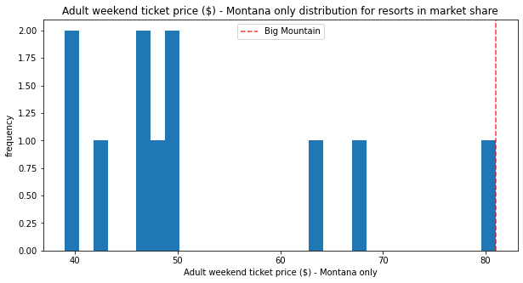

Even though Big Mountain Resort could close runs to lower operating cost I would not recommend this either because even though closing down 1 run has no affect on the ticket price as you close more runs the value of the ticket decreases as shown in the graph below.

